Paying Online
*Only one transaction can be processed at a time.
Go to website: mirainbowlakes.org
- Select Payments

- Select Log In, Create an Account or Make a Payment
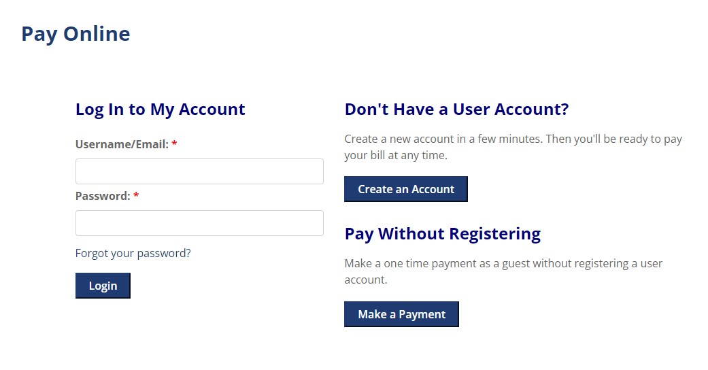

Select Pay with Check or Pay with Credit Card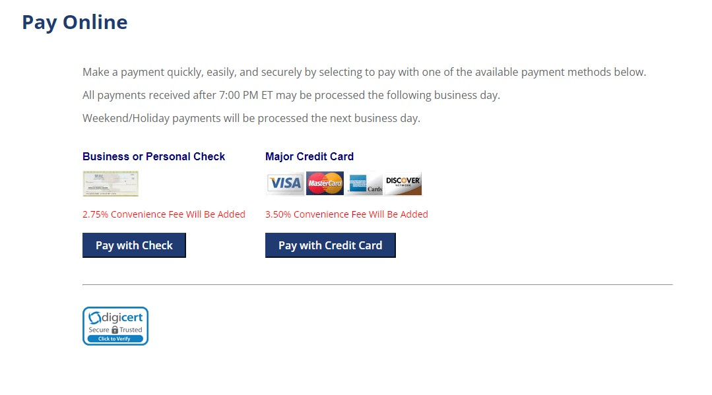

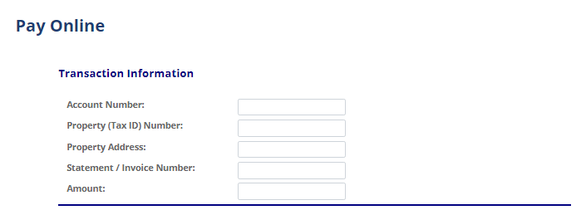
Use this drop down for:
DUES –select YEARLY DUES to pay the yearly charge of $175 (lf you have late fees, these are added further down the screen under Late Fees/Penalties)
$175 will populate automatically
** IF YOUR BALANCE IS LESS THAN $175, SKIP this and enter the amount you will pay under Late Fees/Penalties

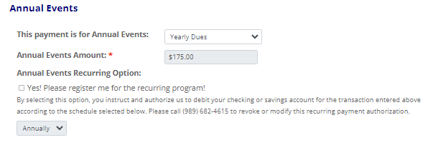
Optional field
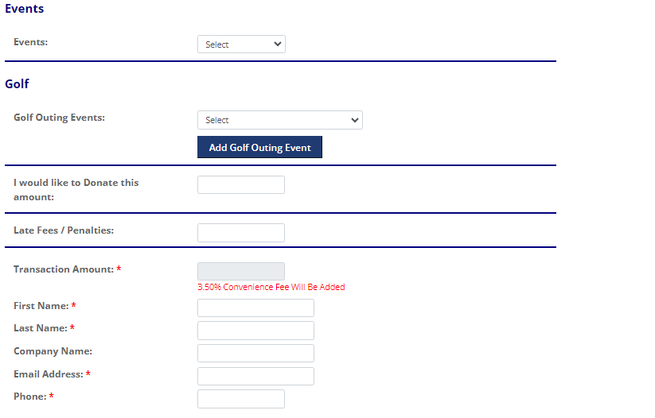
Fill in the remaining fields that have an * next to them
Enter $ amount if either of these apply:
- Late Fees/Penalties
- YOUR TOTAL BALANCE IF IT IS LESS THAN $175

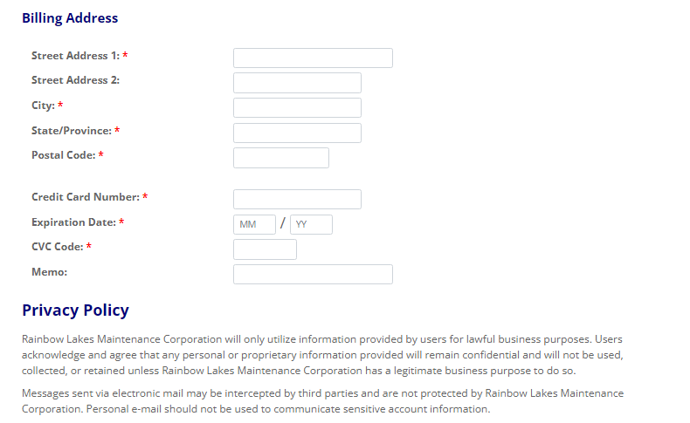
Note: If you are paying with check, account number and routing number fields will be present instead of Credit Card
Card name changes are entered her as well as notes to the office if you are paying for another lake member
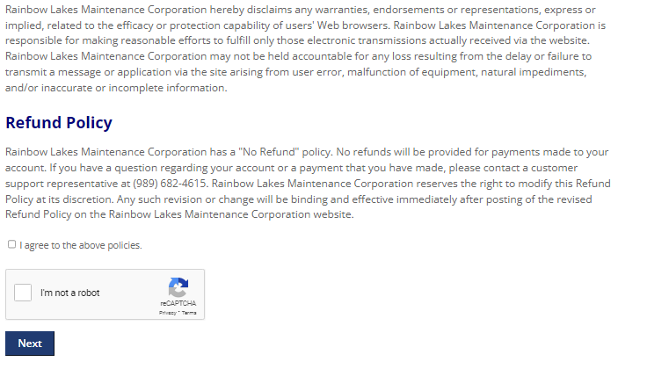

This will take you to the page to enter your payment information. Please make note of any address, phone number, or email changes along with name changes for member access cards if different from the 23-24 season.

